From fixed to collect can be done by ML

Allocate Cost

Print Invoice

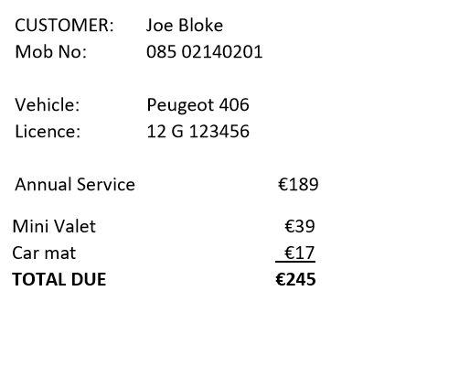

Dexter to ask for permission in runtime (ask for permission to write in the storage)

itextPdfLibrary to create the document

PrintManager to print the document